WOODPECKER CNC
INSTRUCTIONS

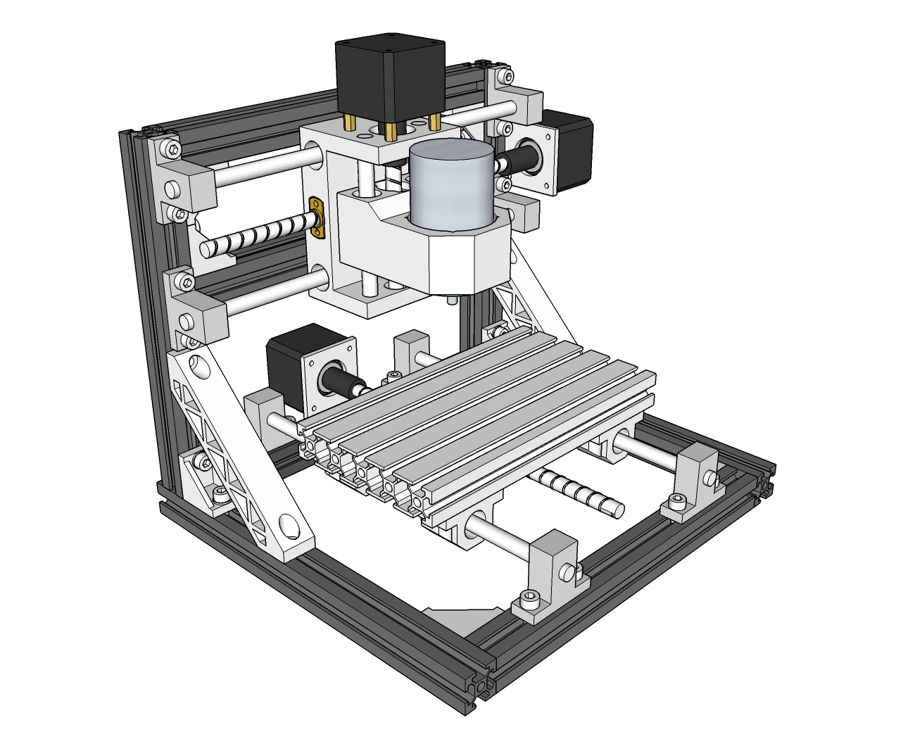
V2.4
- Introduction of some parts and right elevation & left elevation
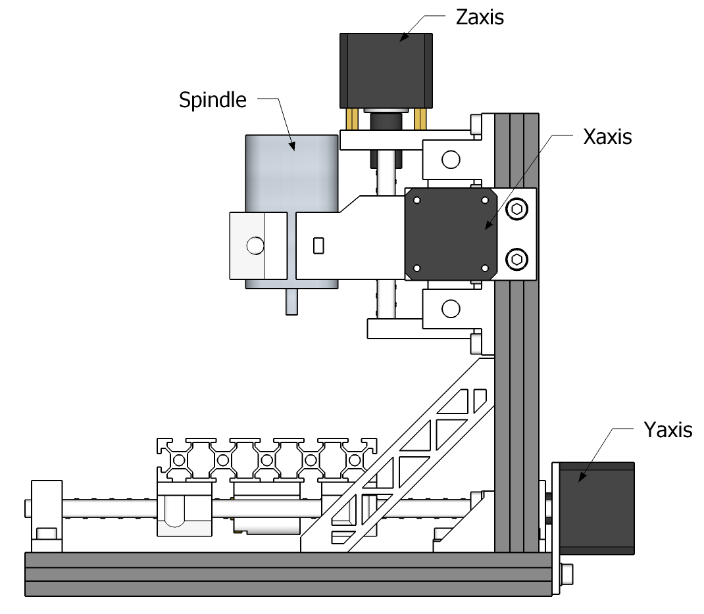
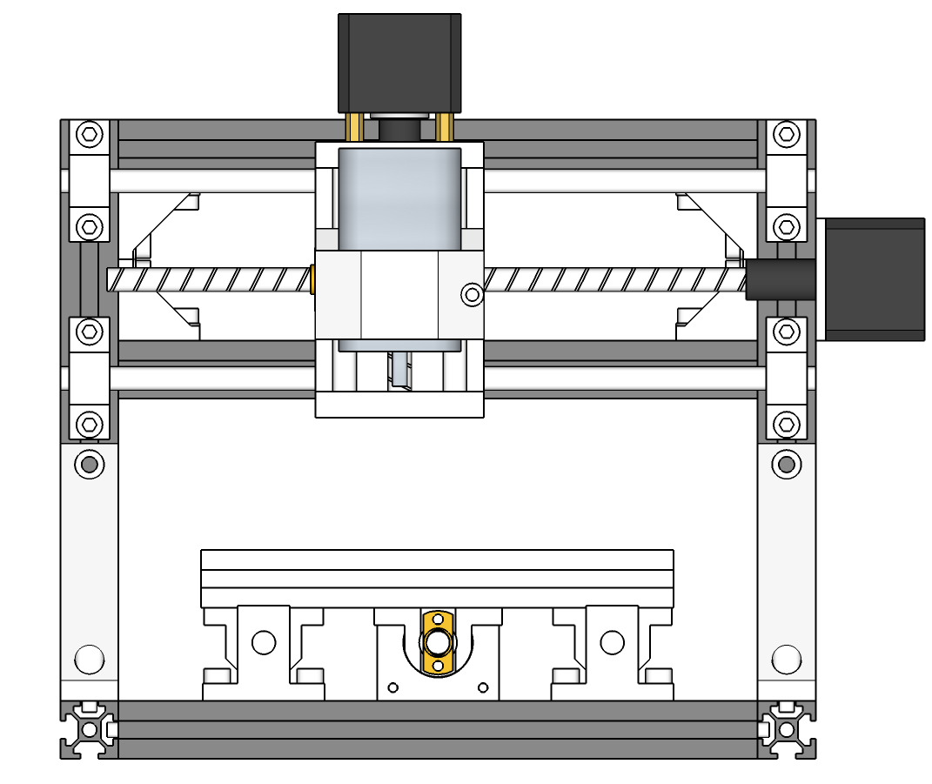
- Size of some parts for X and Z axis
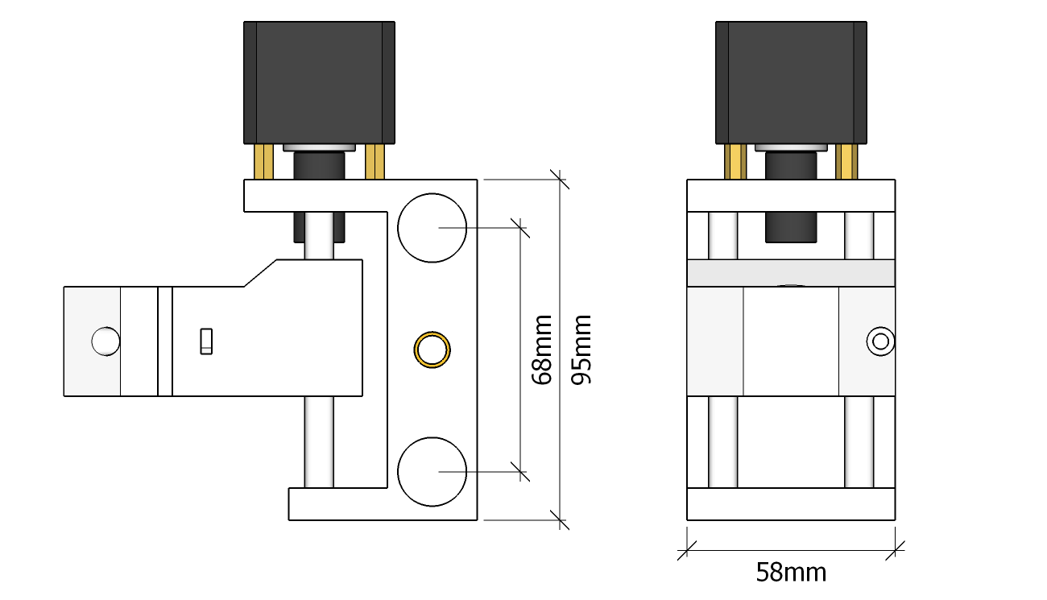
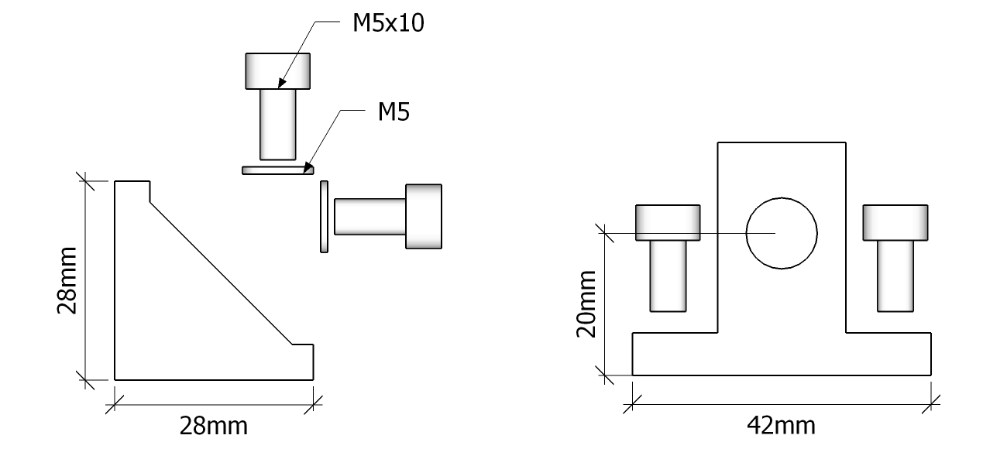
- Assembly Step 1:
Base frame The sizes of the base and upper frame are as picture shows. Assemble them separately but do not put them together.
Notice, please use spacers when assemble the triangle supports.
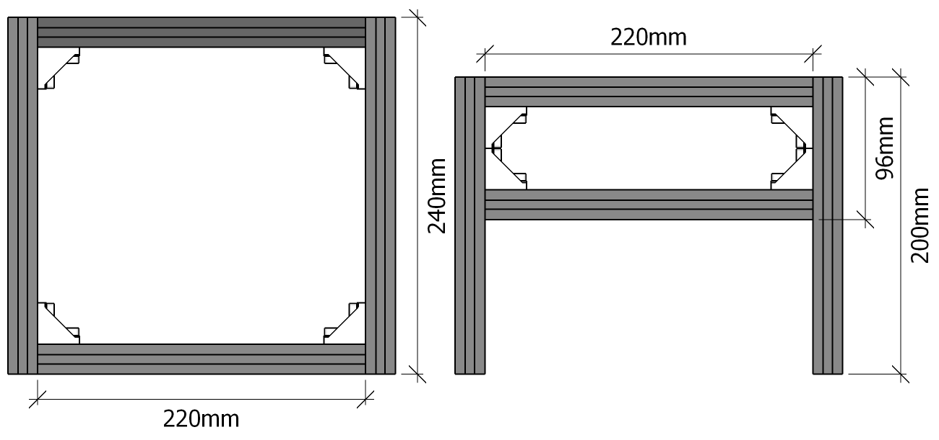
- Step 2
Y axis 1 The suggested distance between the two axis is 120mm, but you can assemble them at your own preference.
Notice: The fix-mount for the polished rods are assemble on the shorter side, as shown below. No spacers are needed for the screws.

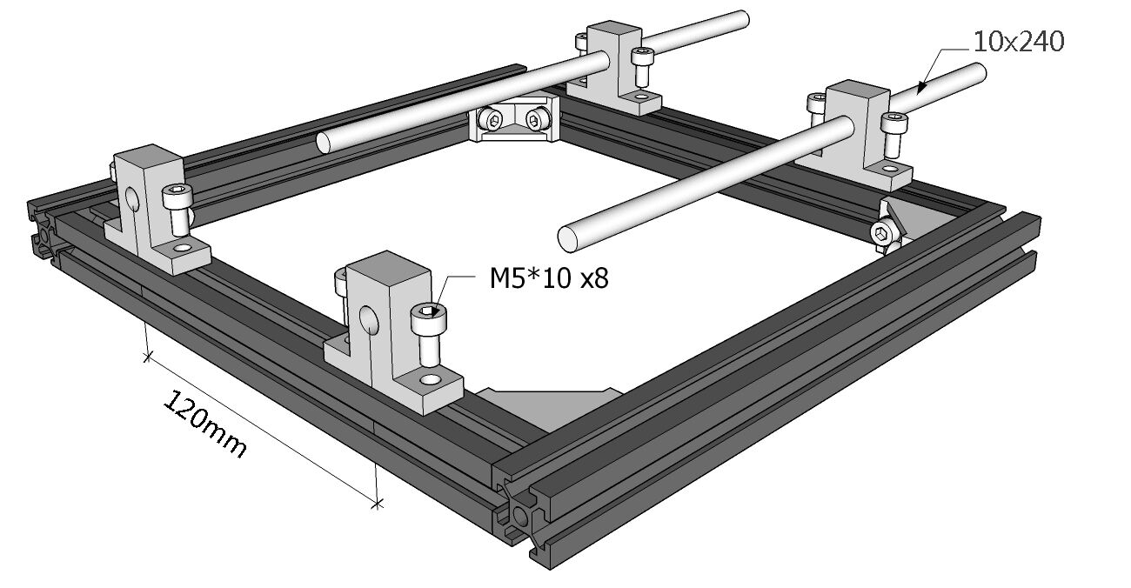
Y axis 2 Assemble the four sliding block as shown below.
Notices: Do not tighten the screws, you may need to adjust them later. No spacers are needed for the screws.
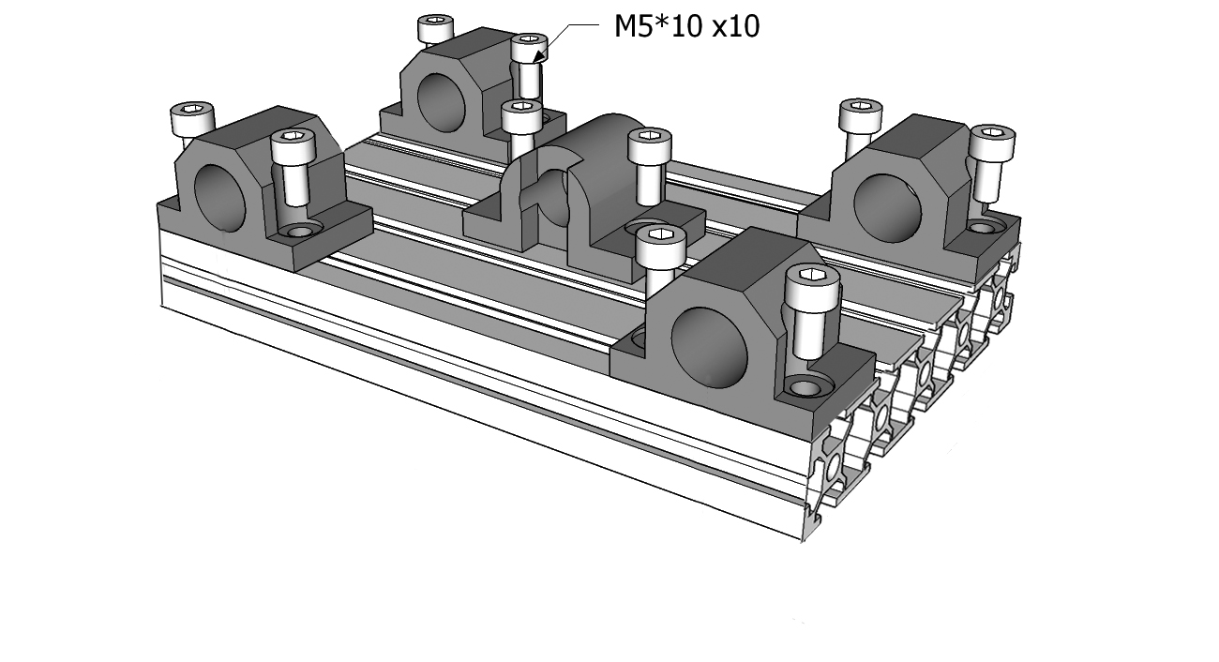
Y axis 3 Put the assembled parts together.
Notice: Do not tighten the screws until you can run the machine smoothly.
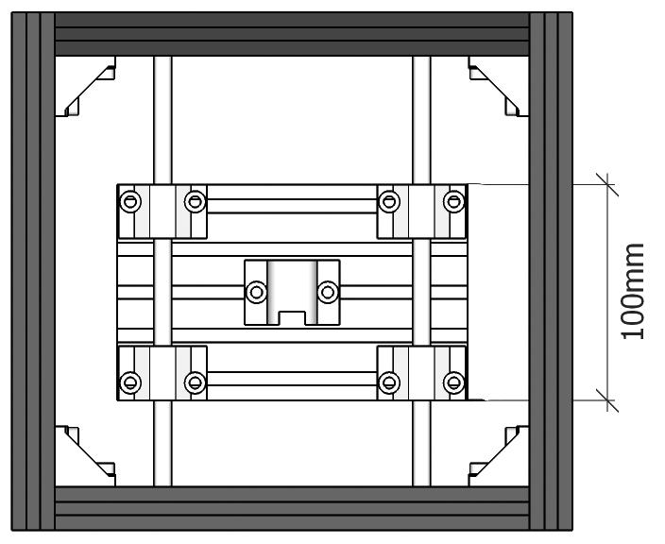
- Step 3 Frame
Notice: Make the distance between the frame to the edge to be 6mm, so the center of the spindle coincides with the center of the Y axis.
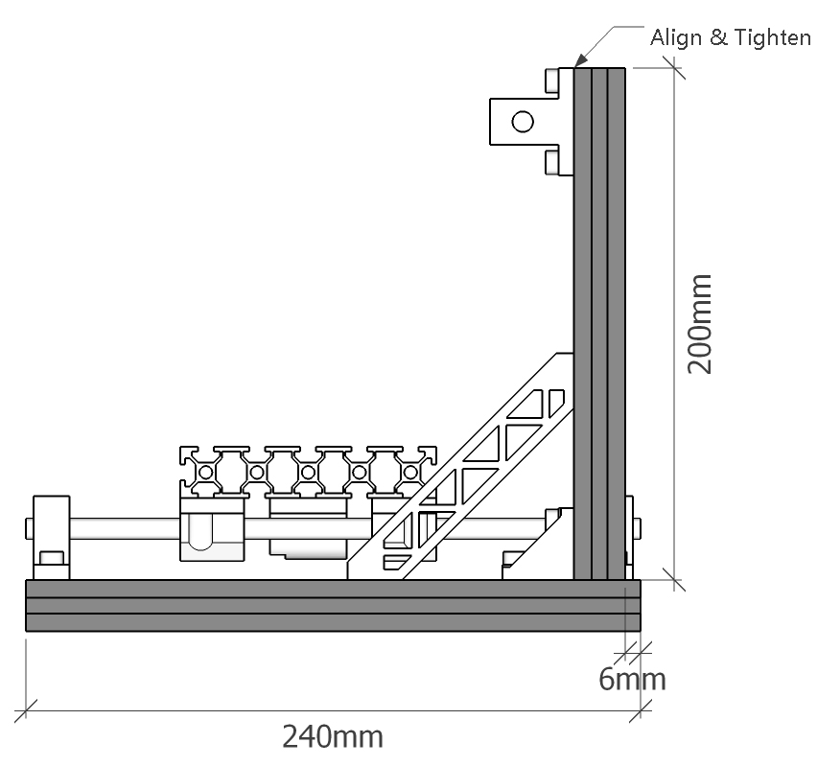
- Step 4: XZ axis assembly Tighten the supporting base at the top, then slide it to the side and tighten it.
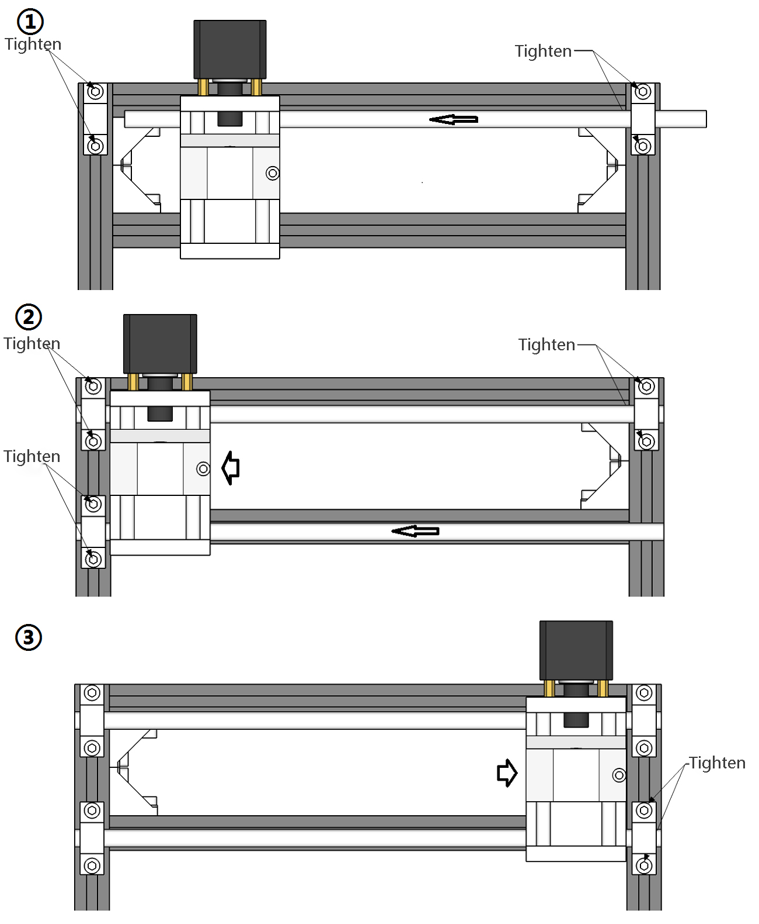
- Step 5 Lead screw and Copper nut
Put the spring into the hole first then pin it with the nut, meanwhile swivel the lead screw to go through the part.
Notice: Pay attention to the sizes of the lead screws. They are different for X axis and Y axis. Do not press the spring too hard.
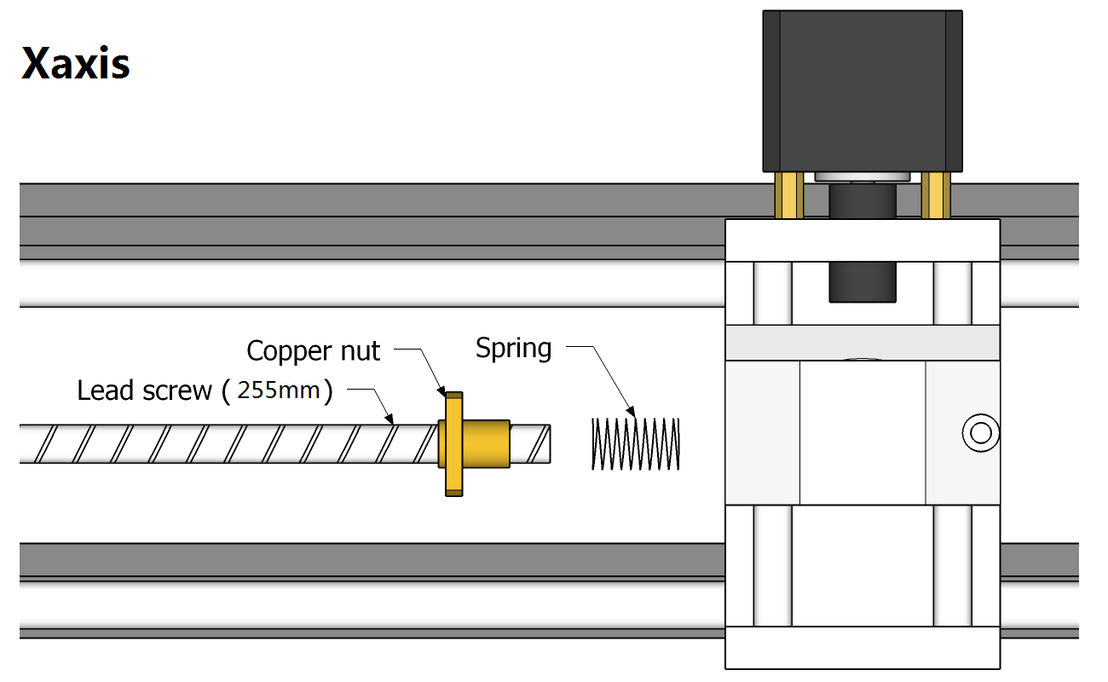
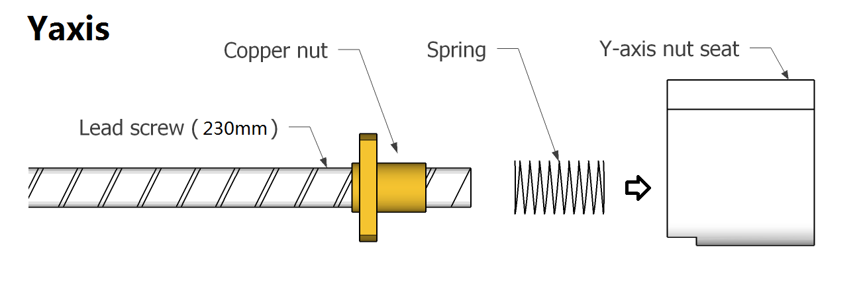
Final assembly result of Y axis lead screw
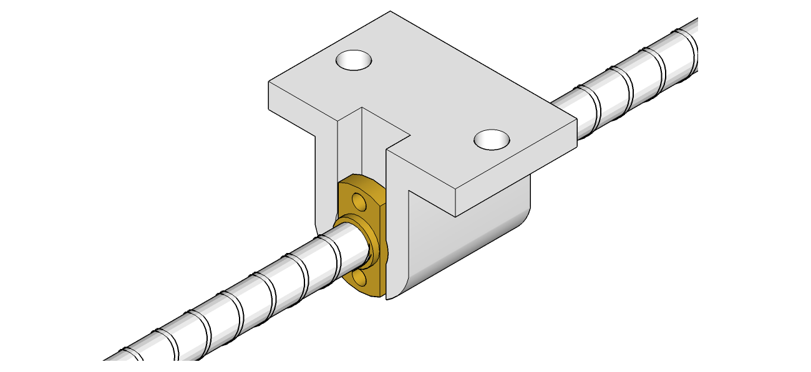
- Step 6 Couplings
Notice: Only tighten the holding screw on one side.
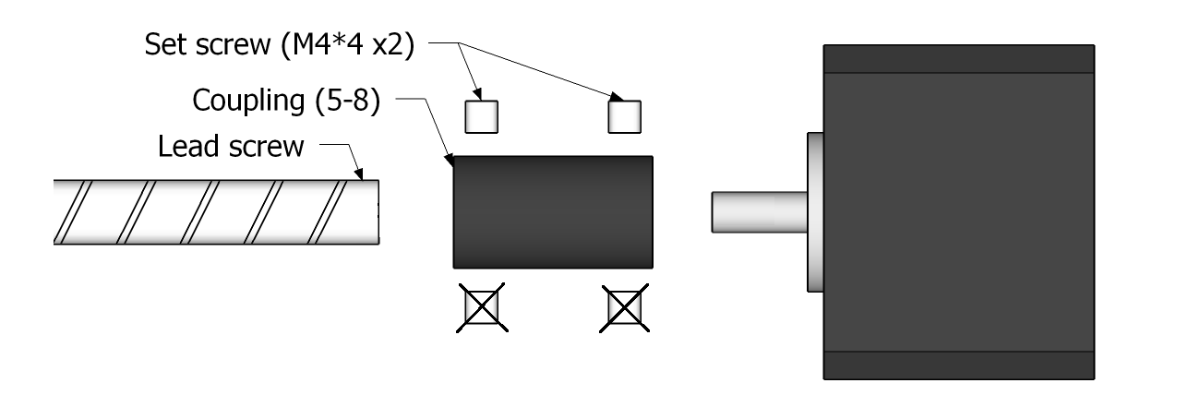
- Step 7 Control board It is suggested to be installed on the right corner at the back of the machine. 4 of M5*10 screws and 4 of M5 nylon gasket to be used.
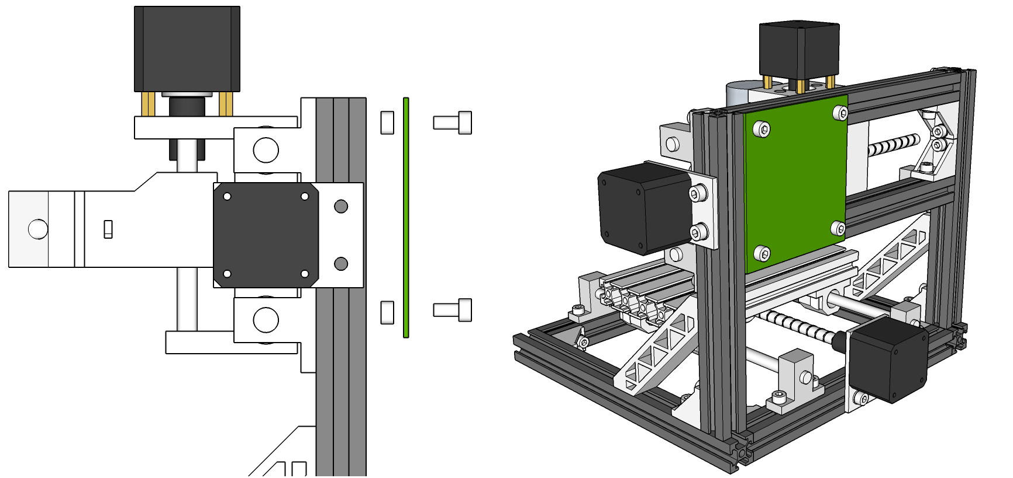
- Step 8 Bearing
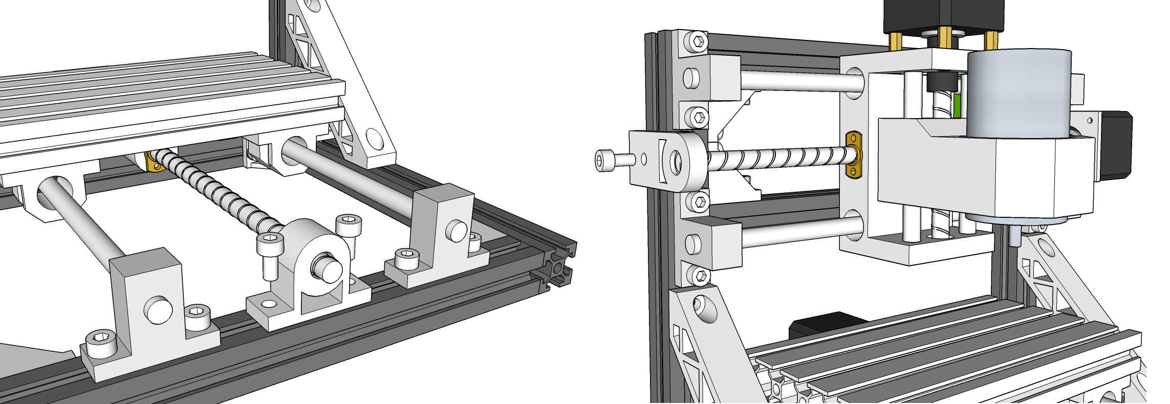
Wiring Diagram
